LAB ASSIGNMENT 9
Landing AI: Vision-Based Cognitive System Cognitive Computing (UCS420)

Name | Ayush Kamboj
Roll No. | 1024160118
Group | 3P14
Platform | LandingLens (Landing AI)

Assignment objectives
- Design a cognitive assistant for locating/reading labels on medicine bottles.
- Design an emotion-aware cognitive assistant using facial-expression classification.

Prepared from the practical work completed in LandingLens. Replace the blank student details on this cover before submission.

Medicine Bottle Label Detection
Objective. Build an object-detection model that identifies a medicine ampoule and its printed label region from an image.
Platform and project setup. A LandingLens project named Medicine_Bottle_Label_Detection was created with the Object Detection project type. A medicine-bottle image dataset was downloaded from Roboflow Universe and a small subset of 15 images was used for this practical.
Dataset preparation and annotation. The 15 images were uploaded. A single object class named Box was created and a bounding box was drawn on each image to mark the target region. The images were divided into 12 training images and 3 development images.
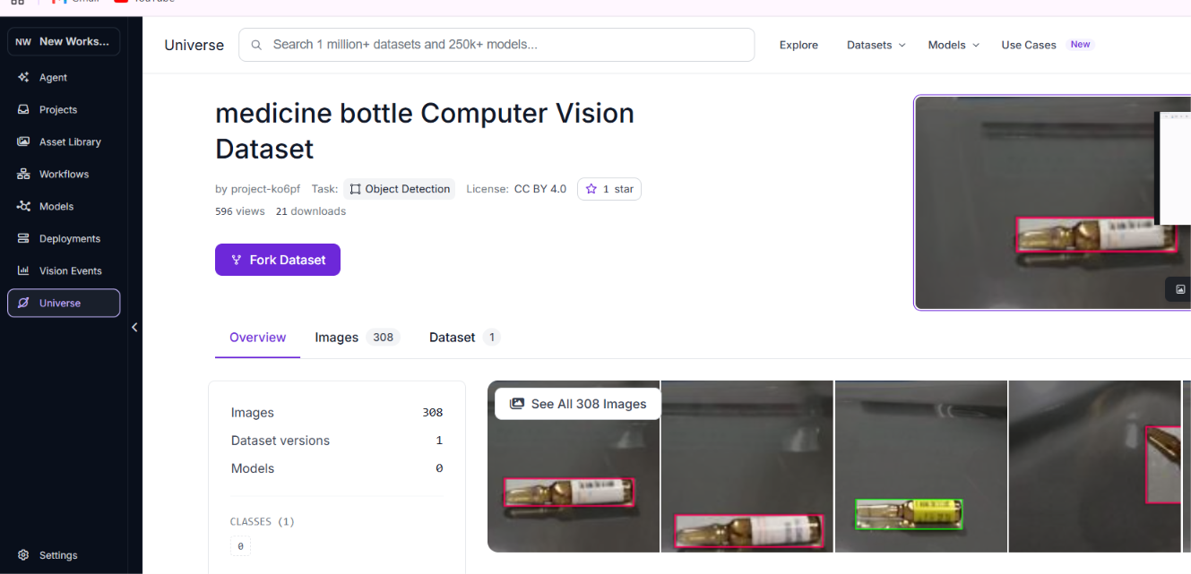
Figure 1. Medicine-bottle dataset preview in the dataset source.
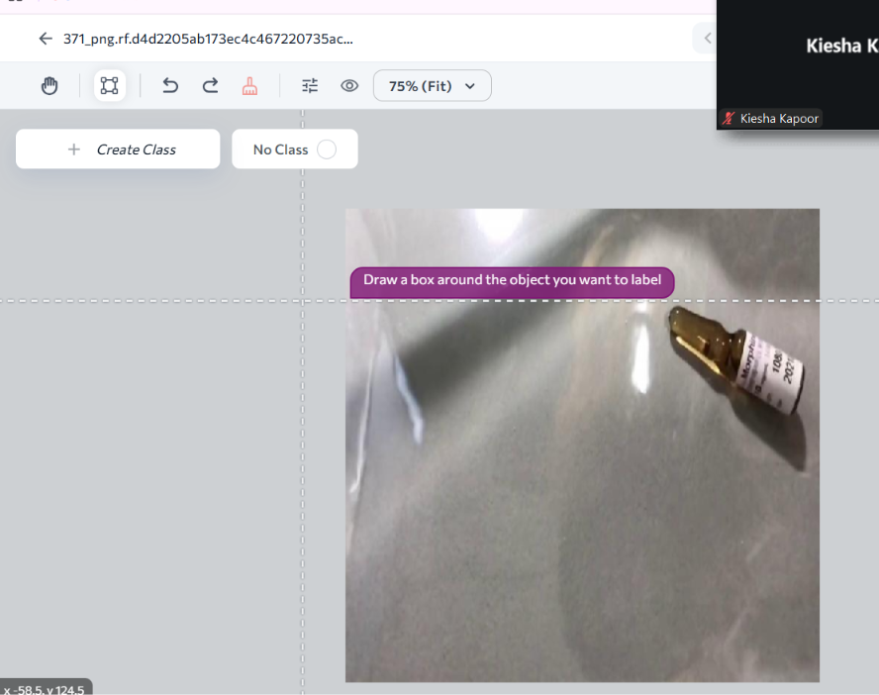
Figure 2. LandingLens annotation editor with the Box class and target bounding box.

Medicine Model Training and Evaluation
Training. The object-detection model was trained from the Build page using 12 training images and 3 development images.
Evaluation results. The completed model displayed 100% on the training set and 100% on the development set. The confusion-matrix view showed 15 correct detections. No separate test set was used for this training run.
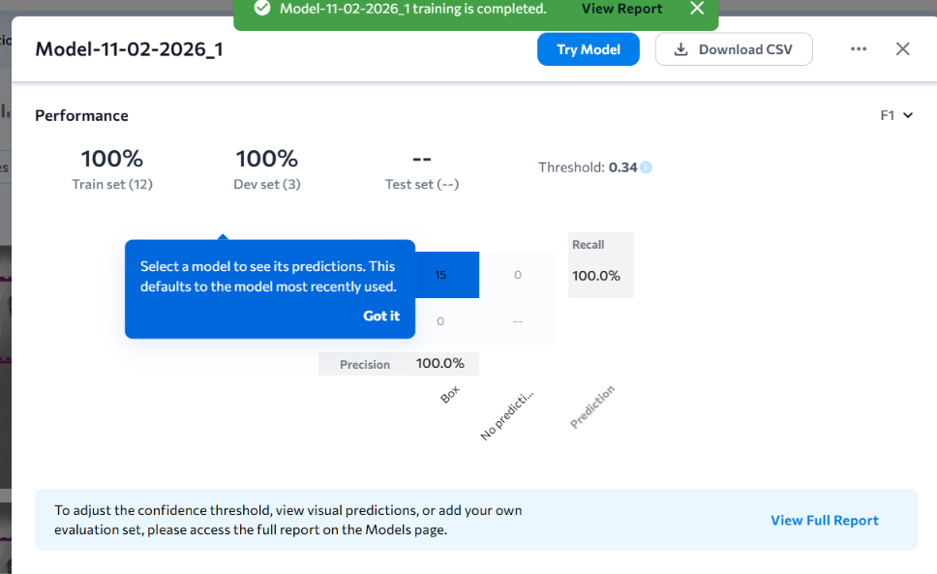
Figure 3. Medicine model performance summary and confusion matrix.

Testing. The Try Model interface was used to run predictions on additional ampoule images. The interface returned one Box prediction for the displayed test image.
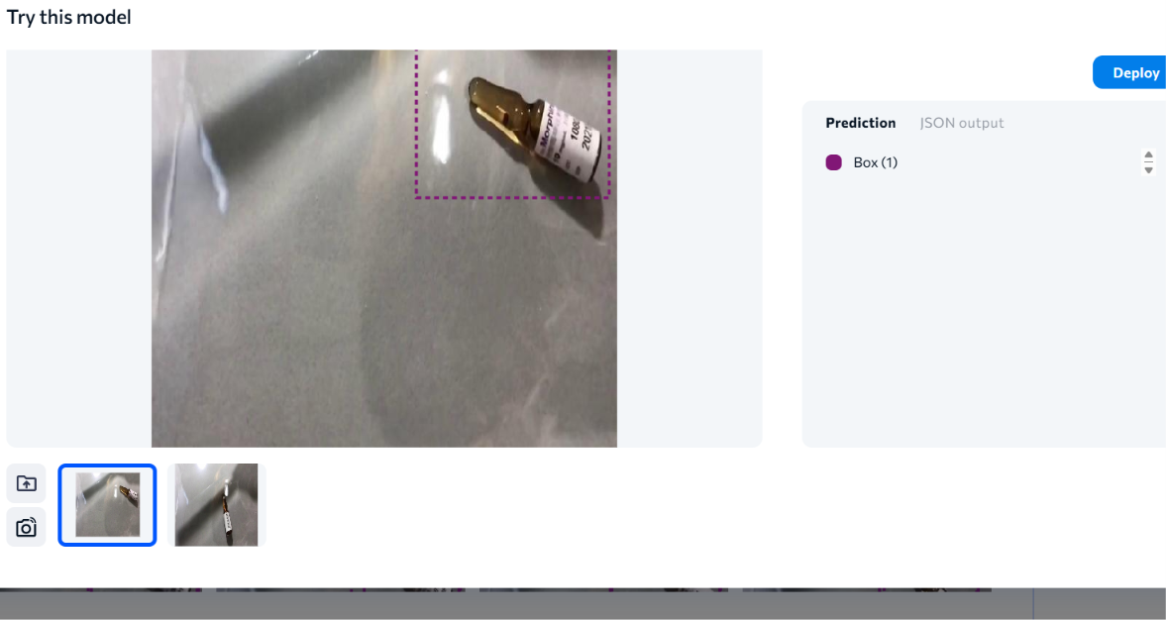
Figure 4. Example prediction in the Try Model interface.

Medicine Model Deployment
The model was deployed through LandingLens Cloud Deployment. The endpoint shown on the Deploy page is named medicine_label. The deployment page also provides API inference examples for the Python SDK, JavaScript SDK and cURL, together with a Mobile Inference QR-code option.
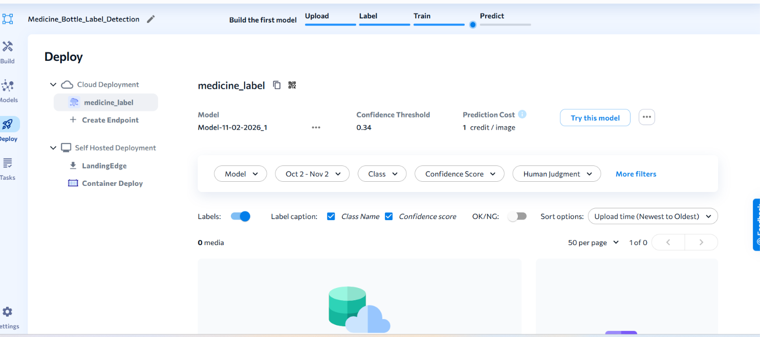
Figure 5. Successful cloud deployment of the medicine model endpoint.
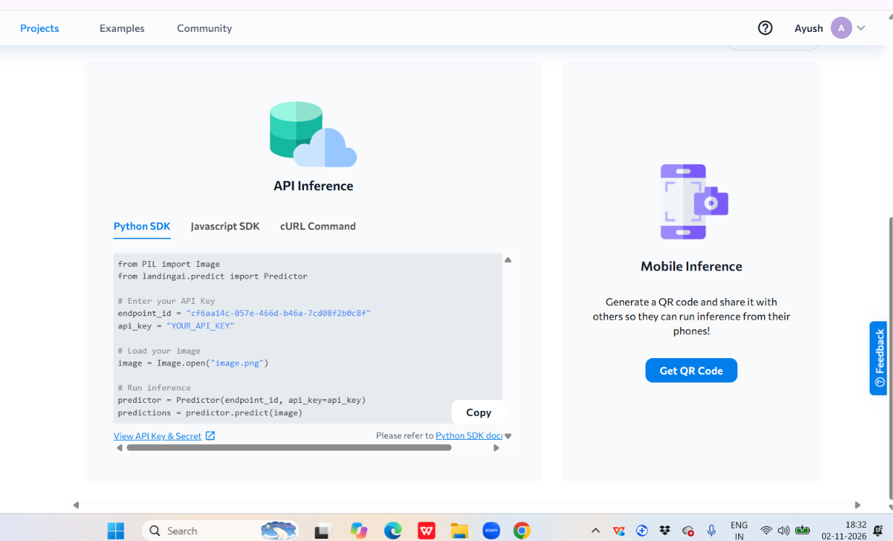
Figure 6. API inference options displayed for the deployed endpoint.
Scope note. The object-detection model localizes the bottle/label region. It does not itself perform OCR or extract the printed medicine name, strength, expiry date or dosage. A separate OCR component would be required for full text reading.

Emotion-Aware Cognitive Assistant
Objective. Build an image-classification model that assigns a facial-expression category to a face image.
Dataset. A small sample of 70 images was prepared from FER-2013: 10 images for each of seven classes — angry, disgust, fear, happy, sad, surprise and neutral. The LandingLens project used the Classification project type because each complete image receives one class label.
Upload and class labels. Images were uploaded by category using the classified-image upload flow, preserving the emotion folder name as the class label. The Build page showed 70 images in total.
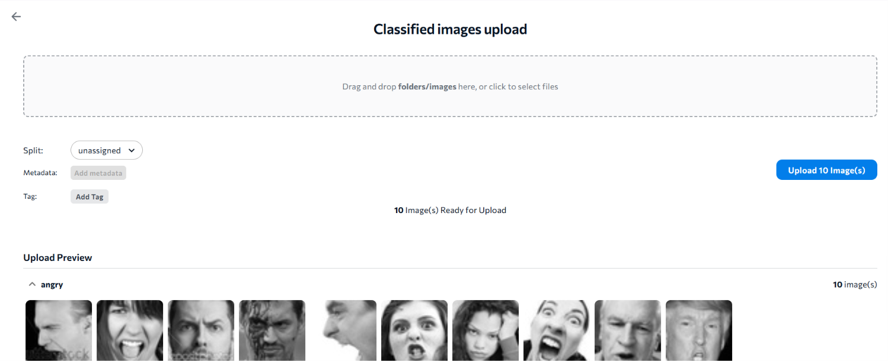
Figure 7. Classified-image upload preview showing the emotion category.
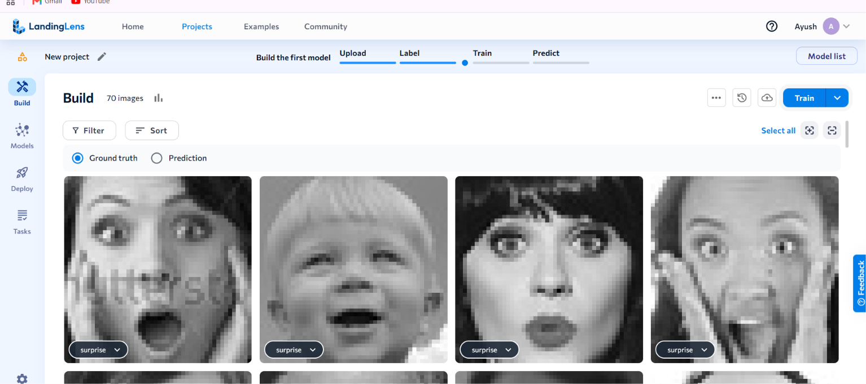
Figure 8. Emotion images displayed in the LandingLens Build page.

Emotion Model Training and Evaluation
The 70 images were split into 56 training images and 14 development images. The final displayed model was Model-11-02-2026_3. Its performance panel showed 21% for the training set and 21% for the development set, with 15 correct and 55 misclassified predictions.
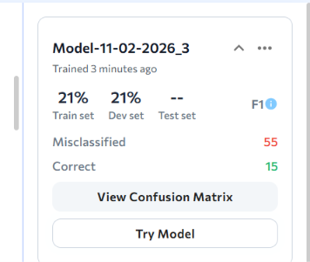
Figure 9. Final emotion model performance summary.

Confusion-matrix observations. The matrix showed that many images from different ground-truth categories were predicted as the same class. The displayed recall values were: surprise 0%, sad 0%, neutral 20%, happy 0%, fear 40%, disgust 90% and angry 0%. This indicates substantial confusion between the expression categories.
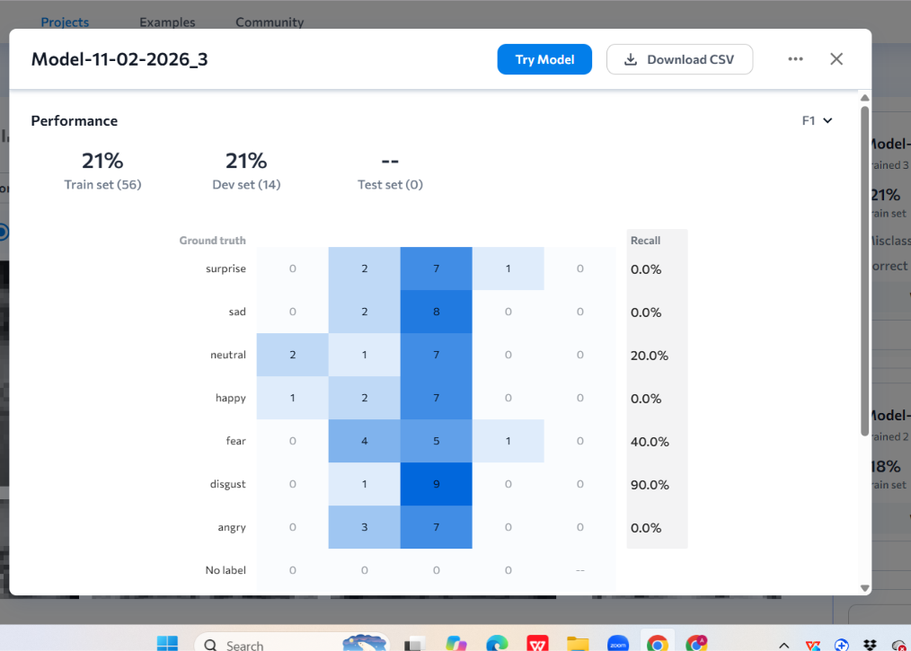
Figure 10. Confusion matrix for the final emotion model.
Interpretation. The result is limited by the very small sample size (10 images per class). The reported score should not be treated as reliable real-world emotion recognition performance. Facial-expression labels describe visible expressions and do not establish a person's internal emotional state.

Emotion Model Testing and Deployment
The trained emotion model was tested through LandingLens' Try Model workflow and was subsequently deployed by the user through the platform's deployment workflow. The final training report and confusion matrix are included above as evidence of the model's measured performance.
Deployment evidence. Add a screenshot of the emotion project's Deploy page here if your instructor requires a separate deployment screenshot. The screenshot should show the endpoint name and deployment status. Do not include API keys or secret credentials in the report.

Suggested screenshot to insert: Emotion_Aware_Cognitive_Assistant → Deploy → Cloud Deployment endpoint. If available, also capture the API inference panel.

Conclusion
Two LandingLens vision-based projects were created. The medicine project used object detection with a Box class, was evaluated on a small 12/3 train/dev split and was deployed as the medicine_label cloud endpoint. The emotion project used classification with seven facial-expression classes and was deployed after training. Its final displayed accuracy was 21% on both train and dev sets, showing that the small sample was insufficient for reliable separation of all seven categories. More balanced and diverse labelled images, careful label verification and further model iteration would be needed to improve the emotion classifier.

Important limitations
  - The medicine object detector identifies a visual region; OCR is required to read the text printed on the label.
  - The emotion model classifies facial-expression appearance, not a person's true internal emotion.
  - The emotion model's 21% results and small 70-image dataset indicate limited performance and should be reported transparently.
Before submission: fill in your name, roll number and group on the cover; add the emotion deployment screenshot if required; verify that the screenshots are legible; and follow your instructor's formatting requirements.

